Product features |   
- DMX dimming isolated adjustable power LED driver
- 2Channel Intelligent DC to DC LED driver |  | 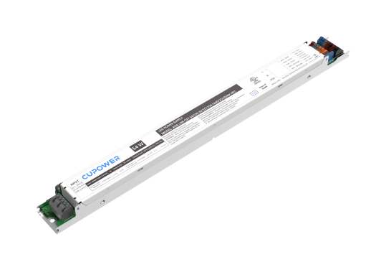
- Flicker-free LED driver |  |  | 
- 12 V 0.1 A Auxiliary source
- Current adjustment via NFC
- NTC use for lamp temperature acquisition or output current set
- Output current 150…1400 mA
- Max. output power 54 W
- Constant lumen output (CLO)
- For luminaires with protection class I,II
- 5 years warranty

Product specifications
165773 | XNA LNR CST 54/120-347/CC150-1400/2CH/DMX NFC
Output current |  | Input voltage | Output voltage |  | Efficiency  @ full load | Current accuracy | Power factor | Dimension  LxWxH (mm)
150 mA |  | 120 Vac | 10…54 Vdc |  | 83% | ± 5% | 0.9 @＞10 W load | 360 x 30 x 21
350 mA |  |  | 10…54 Vdc |  | 86%
750 mA |  |  | 10…54 Vdc |  | 89.5%
1000 mA |  |  | 10…54 Vdc |  | 89.5%
1200 mA |  |  | 10…45 Vdc |  | 88%
1400 mA |  |  | 10…38.5 Vdc |  | 88%
150 mA |  | 347 Vac | 10…54 Vdc |  | 79.5% |  | 0.9 @＞40 W load
350 mA |  |  | 10…54 Vdc |  | 86%
750 mA |  |  | 10…54 Vdc |  | 89%
1000 mA |  |  | 10…54 Vdc |  | 89.5%
1200 mA |  |  | 10…45 Vdc |  | 88.5%
1400 mA |  |  | 10…38.5 Vdc |  | 88%
Electrical specifications
Mains voltage supply
Rated input voltage range |  |  |  | 120…347 Vac; performance range
Max. input voltage range |  |  |  | 108...380 Vac; operational safety range
Rated frequency range |  |  |  | 50/60 Hz
Performance / Operational safety |  |  |  | 47...63 Hz
Max. input current |  |  |  | 0.58 A @ 120 Vac
Protection against voltage peaks
Withstand voltage |  |  |  | I/p-O/p: 1.8 kVac, < 5 mA 60 s; I/p-FG: 1.8 kVac, < 5 mA 60 s  I/p-DIM: 1.8 kVac, < 5 mA 60 s; DIM-FG: 0.6 kVac, < 5 mA 60 s  O/p-FG: 0.6 kVac, < 5 mA 60 s
Mains surge immunity |  |  |  | L-N 1 kV, L/N-FG: 2kV per IEC 61000-4-5
Ringing wave |  |  |  | L-N 2.5 kV, L-FG 2.5 kV, N-FG 2.5 kV
Total harmonic distortion (THD)
At rated input voltage range @ full load |  |  |  | ≤ 10% @ 120 Vac; ≤ 20% @ 347 Vac

Output data
Output current tolerance | ± 5% at rated input voltage range
No load output voltage | 60 Vdc
Ripple output current | 5% (ripple = peak/average tota 100/120 Hz)
Output PstLM | ≤ 1 at full load @ rated input voltage
Output SVM | ≤ 0.4 at full load @ rated input voltage
Protection functions output side
Over voltage protection | The output voltage is less than or equal to 60 V  Over voltage protection: Hiccup mode. protection device will trigger when load voltage exceeds specified output voltage and will auto recover after the fault mode is removed.
Overpower protection | The output power is less than or equal to 59.4 W
Short circuit protection | Short circuit protection: Hiccup mode. Protection device will trigger when short circuit and will auto recover after the fault mode is removed.
Dimming operation and interface
Dimming current range | 1%…100%
Standby power consumption | < 0.5 W
Connection terminals
Connection terminal type | 45° push in terminal
Wire cross section | lnput and output wire: 18-20 AWG
Wire stripping length | 9…10 mm
Degree of protection
Protection rating | IP20
Operating data
Output current range | NFC control adjusts the current: 150…1400 mA
Default current | 150 mA
Output voltage range | 10…54 Vdc
Noise level | < 20 dB, at full load @ 100 cm distance
Supplementary instructions
- The luminaire manufacturer is responsible for measuring and verifying the EMl compliance of the complete luminaire, as the level of radio interference will vary depending on the luminaire construction. Especially primary and secondary cable lengths and their routing may have a significant effect on radio interference.

Environmental specifications
Operating temperature | -20…+50°C
Storage temperature | -25…+85°C
Working humidity | 5%…90%
Store humidity | 5%…95%
Lifetime | at Tc 90°C: 50,000 hrs; at Tc 80°C: 100,000 hrs @ 120 Vac  （0.2% / 1,000 h failure rate）
Maximum Tc temperature | 90°C
Safety & EMC compliance
UL |  |  | CCC |  |  | SAA
Dimensions
Housing dimensions |  |  | Packaging details
Length (L) | 360 mm |  | Packing units | 20 pcs
Width (W) | 30 mm |  | Carton size | 381 x 128 x128 mm
Height (H) | 21 mm |  | Weight | 6.4 kg
Weight | 0.269 kg
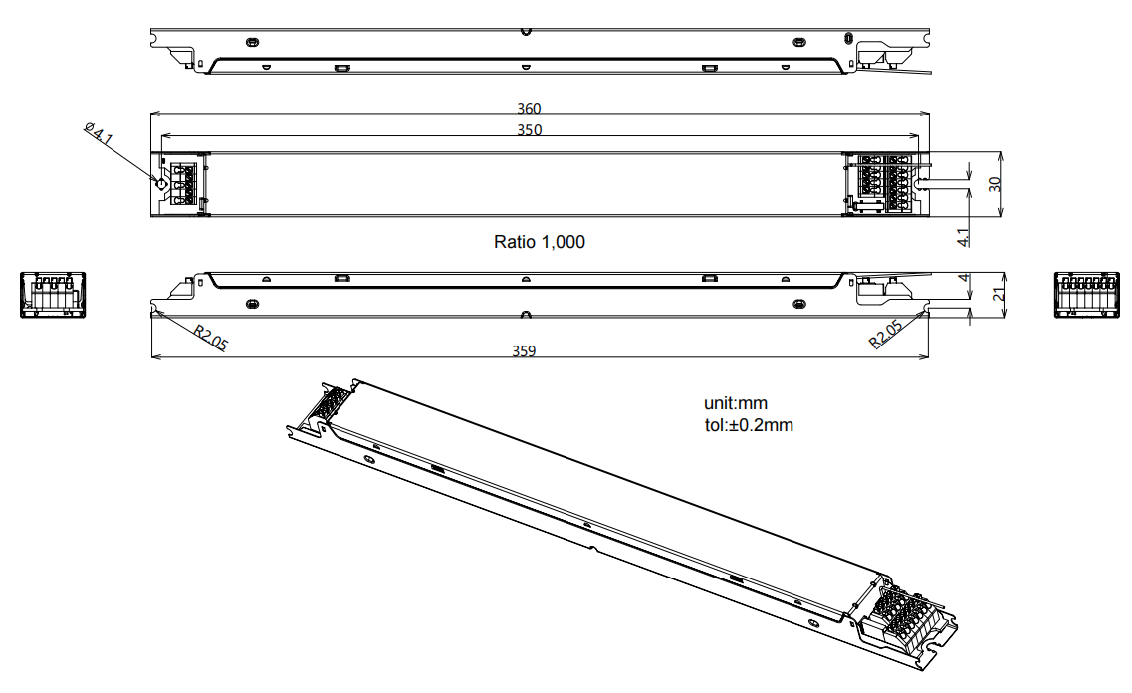

Wiring diagram
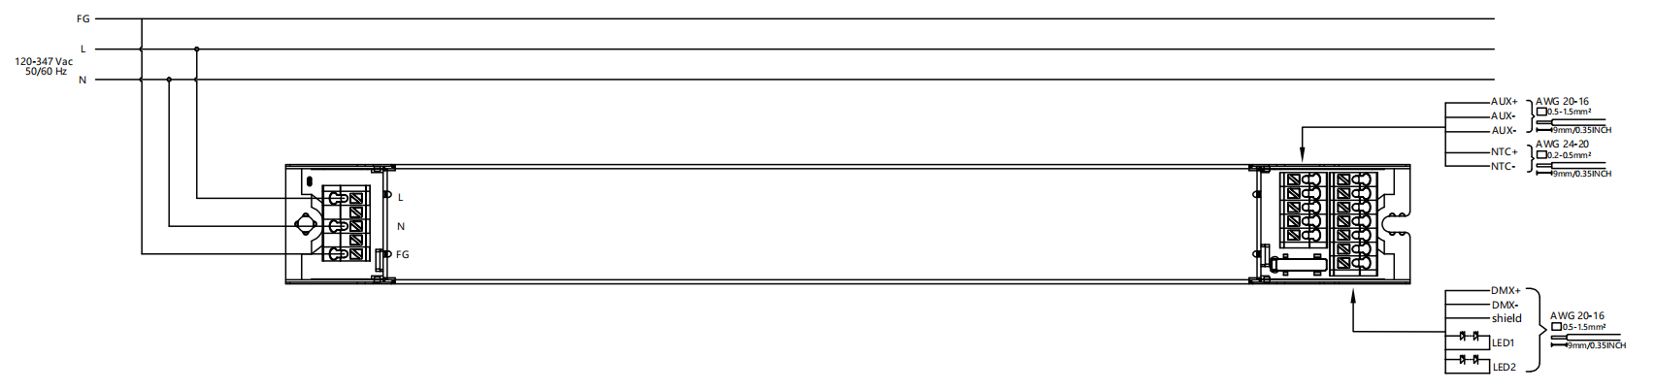

- All connections must be as short as possible to ensure good EMl performance.
- The luminaire wire should keep a certain distance from the LED power supply and other wires (5…10 cm is preferred).
- No secondary switches are allowed.
- Incorrect wiring can damage the LED.
- The wire must be well protected against short circuit.
MCS ±
- NTC + / - interface voltage 3.3 V
- Could connect to external NTC
NTC thermal management protects LED lamp , when the temperature of LED lamp over temperature protection point ,
the current will be reduced by 50% every 5 minutes . Default setting is 85°C .
- NTC compatibility list :

NTC Manufacturer | NTC Mode lNO .
MURATA | NCP21WB473J03RA
VISHAY | NTCS0805e4473JXT
VISHAY | NTCLE100E3473

Technical information
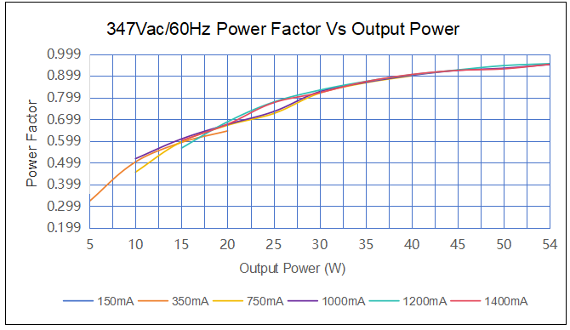

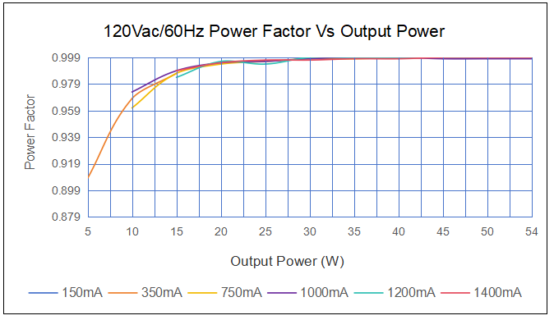

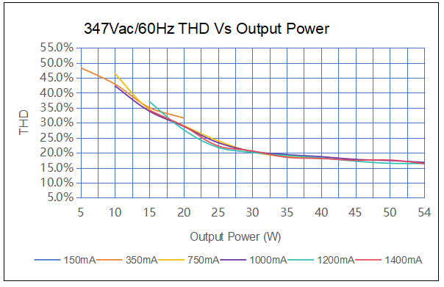
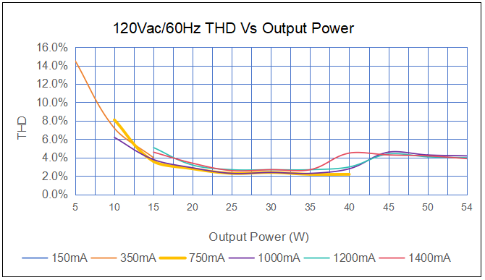

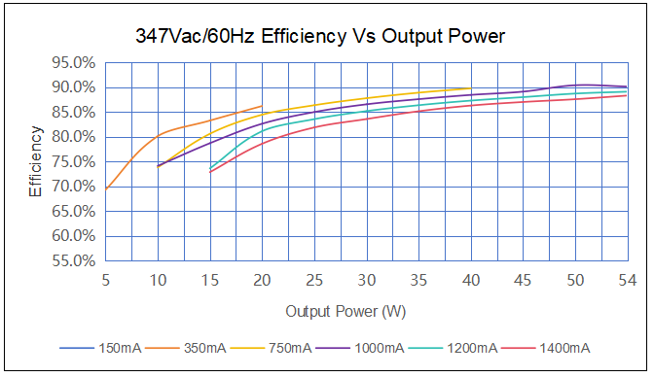
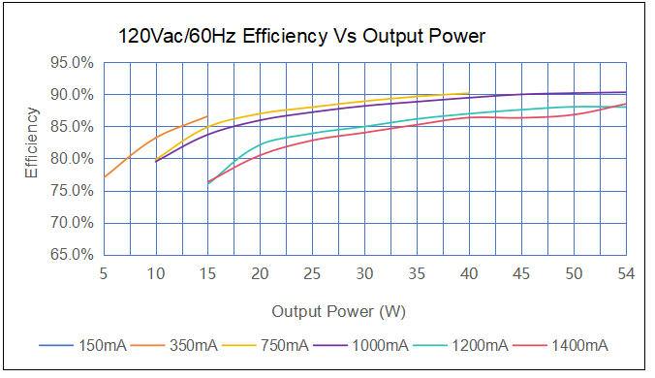

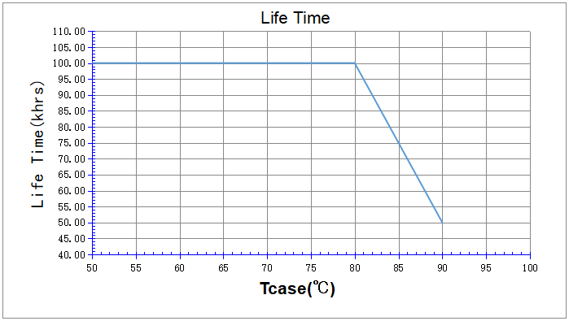
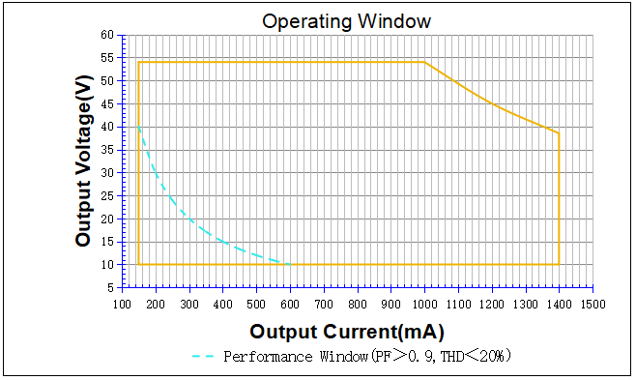

 | It's important to set the output current (AOC value) according to the LED voltage and make sure the power is within 54 W + 5%.
 | Example of AOC settings
 | V LED (Vdc） | AOC max | Pout (W）
 | 54 | 150 mA | 8
 | 54 | 350 mA | 19
 | 54 | 750 mA | 40
 | 54 | 1000 mA | 54
 | 45 | 1200 mA | 54
 | 38.5 | 1400 mA | 54

